
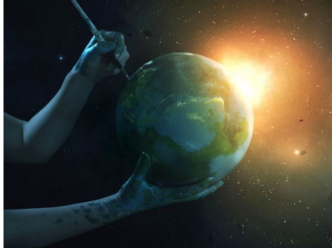




צְדָקָה
2 Peter is concerned about false teachers who are saying that the Lord will not return because he hasn’t yet. (Notice similarities to Jude.)
Our vision of the future shapes how we live in the present

Second Sunday of Advent: Living holy lives is a posture of waiting for and desiring the new creation where rightesouness dwells
2 Peter 3:8-15
⁸ Don’t let it escape your notice, dear friends, that with the Lord a single day is like a thousand years and a thousand years are like a single day. ⁹ The Lord isn’t slow to keep his promise, as some think of slowness, but he is patient toward you, not wanting anyone to perish but all to change their hearts and lives. ¹⁰ But the day of the Lord will come like a thief. On that day the heavens will pass away with a dreadful noise, the elements will be consumed by fire, and the earth and all the works done on it will be exposed.
¹¹ Since everything will be destroyed in this way, what sort of people ought you to be? You must live holy and godly lives, ¹² waiting for and hastening the coming day of God. Because of that day, the heavens will be destroyed by fire and the elements will melt away in the flames. ¹³ But according to his promise we are waiting for a new heaven and a new earth, where righteousness is at home. Therefore, dear friends, while you are waiting for these things to happen, make every effort to be found by him in peace—pure and faultless. ¹⁵ Consider the patience of our Lord to be salvation

Malachi 3:2-3 Who can endure the day of his coming?
Who can withstand his appearance?
He is like the refiner’s fire or the cleaner’s soap.
³ He will sit as a refiner and a purifier of silver.
He will purify the Levites
and refine them like gold and silver.
They will belong to the Lord
presenting a righteous offering.
Like a Thief
1 Thessalonians 5:2
Matthew 24:43
Luke 12:39
Revelation 16:15
Ps 90:3-5 You return people to dust,
saying, “Go back, humans,”
⁴ because in your perspective a thousand years
are like yesterday past,
like a short period during the night watch.
⁵ You sweep humans away like a dream,
like grass that is renewed in the morning.

